**INF10002** High Distinction Task

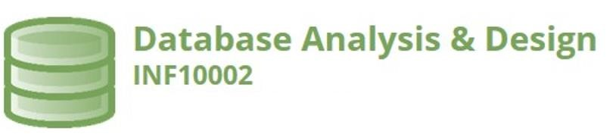

# High Distinction Task S1 2023

Student ID: 103542974

Student Name: Hai Hoang Le

**Part 1 – Business Narrative**

Paste content here.

StudentID: 103542074 ( ends with 4 )

**Business type: Handling tasks for a House cleaning business**

We believe that a relation databse can greatly assist database solution in many ways:

* A relational database solution allows the cleaning business to store and retrieve large amout of data, such as customer information, cleaning schedule in an organised and efficient manner
* Improved the data accuracy and consistency. A relational database can store data in accuracy and consistency across many tables and records.
* Better data analysis and reporting: With the data stored in a relational database, data analysis can use tools such as PowerBi to visualized the trends of the business. Reports can generated an overview the business’s performance. Finally, to have the ability to orientation for the business.

**Scenario**:

The house cleaning business operates by providing cleaning services to residential customers. Customers can request cleaning services by phone, email, or through the company's website. The company assigns a cleaning team to each customer based on the customer's location, cleaning needs, and availability.

The data involved in this business includes various entities and attributes, such as:

* Customers: name, address, phone number, email address
* Cleaning service: service code, service description, servicerate
* Cleaning teams: team members, availability, location
* Cleaning schedules: date and time of cleaning, duration, location
* Invoices: Invoices number, customer name, date of service, total cost

It is useful for this organization to use a database to store this data because it enables efficient storage, retrieval, and management of large amounts of information. A database also facilitates data analysis and reporting, enabling the business to make informed decisions and optimize its operations.

The business rules that apply to the data include:

* Each customer can request cleaning services on a recurring or one-time basis
* Each cleaning team can be assigned to multiple customers
* Each cleaning team can only be assigned to one location at a time
* Each cleaning schedule must be confirmed by the customer before the cleaning takes place
* Invoices must be generated for each cleaning service and sent to the customer

To provide useful outcomes, the business could use queries to retrieve specific information, such as all cleaning schedules for a particular day. Reports could be generated to provide an overview of the business's performance, such as the number of cleaning services provided each month. Visualizations could be used to identify trends and patterns in the data, such as the busiest times of day or week for cleaning services. Overall, the use of a database can help the house cleaning business operate more efficiently and effectively.

**Part 2 – ERDs and Relational Schema**

**ERD:**

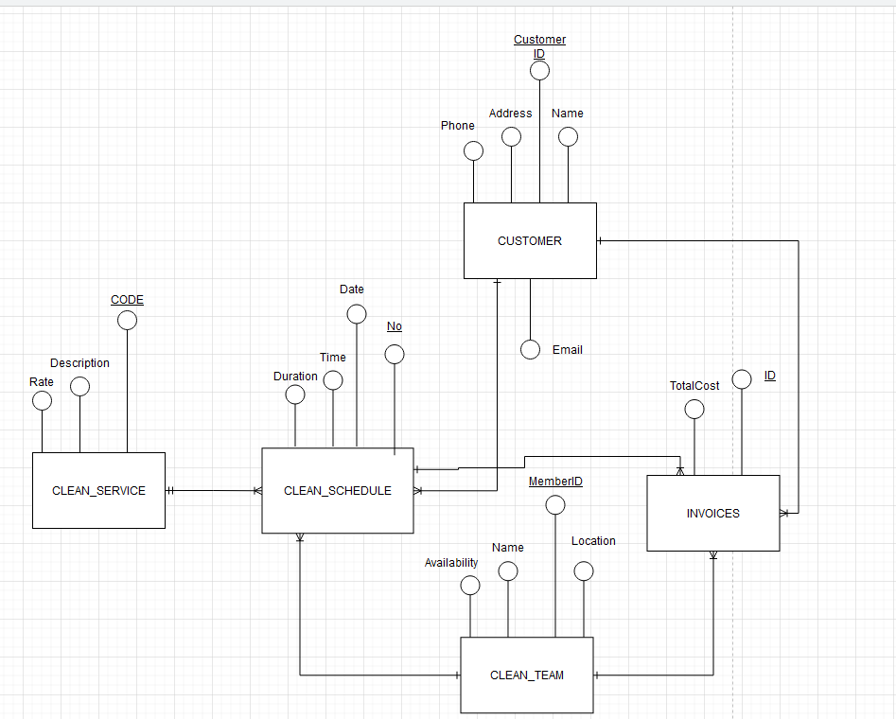

**Relational schema:**

CUSTOMER (CustomerID, Phone, Address, Name, Email)

PK CustomerID

CLEAN_SERVICE (Code, Description, Rate)

PK (Code)

CLEAN_TEAM (MemberID, Name, Location, Availability)

PK (MemberID)

CLEAN_SCHEDULE (No, Date, Time, Duration, CustomerID, MemberID, Code)

PK ( No, CustomerID, MemberID, Code)

FK1 CustomerID references CUSTOMER (CustomerID)

FK2 MemberID references CLEAN_TEAM (MemberID)

FK3 Code references CLEAN_SERVICE (Code)

INVOICES (ID, TotalCost, CustomerID, MemberID, InvoiceNo)

PK ( ID, CustomerID, MemberID, No)

FK1 CustomerID references CUSTOMER (CustomerID)

FK2 MemberID references CLEAN_TEAM (MemberID)

FK3 InvoiceNo references INVOICES(No)

**Part 3 – DB Solution (If using Access then file is to be uploaded to Canvas)**

**(If using SQL then Drop Table, Create Table, Insert Statements are pasted here)**

Relational Diagram (MS Access)

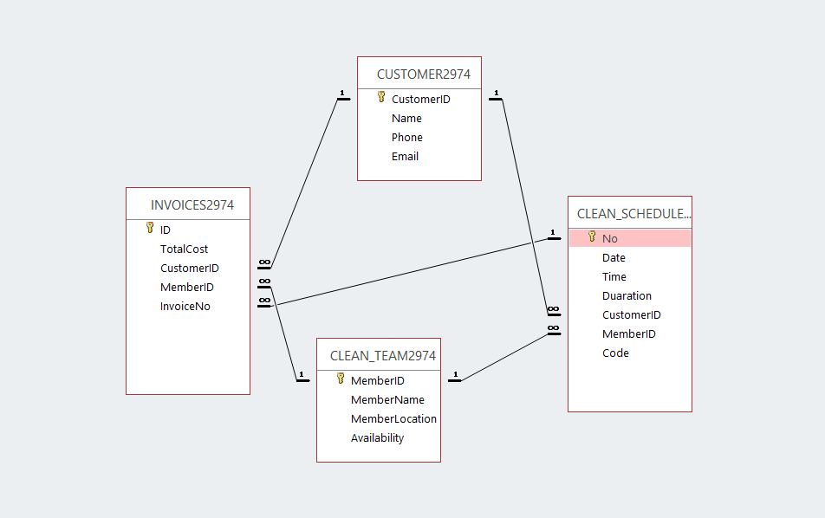

**Part 4 – Test Data (Diagram and/or Statements)**

Design Views/Datasheet views or Sql scripts - Paste here.

Table 1

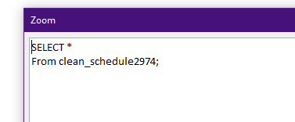

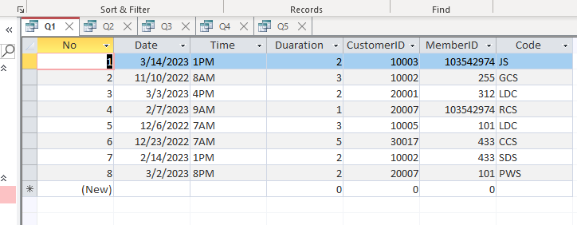

Table 2

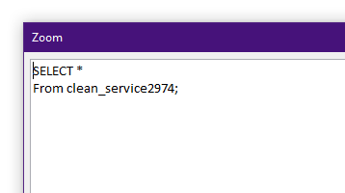

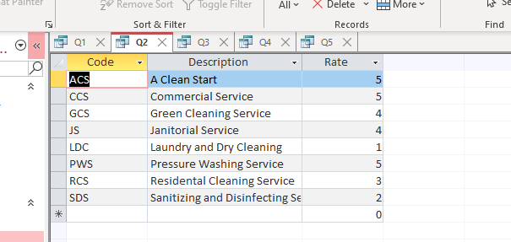

Table 3

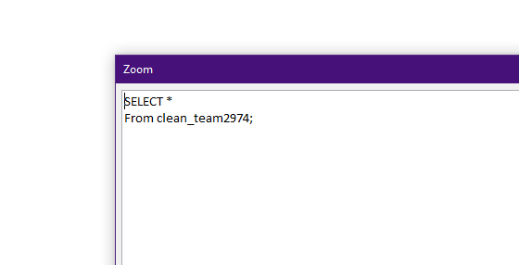

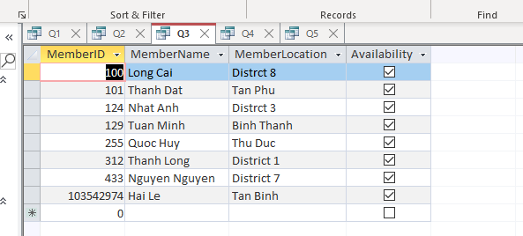

Table 4

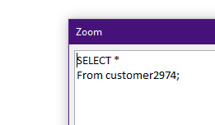

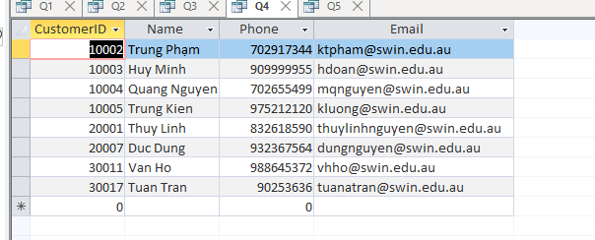

Table 5

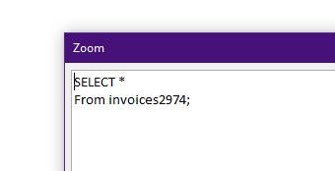

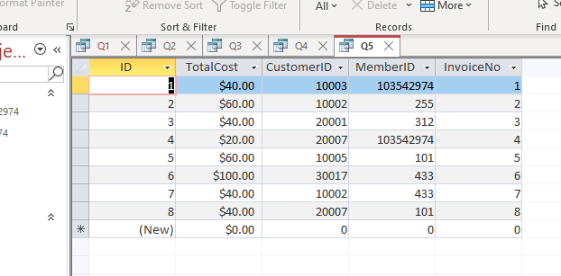

**Part 5 – Queries, Visualisations, (i.e. Queries or sql scripts)**

Paste here.

Q6: List all clean member that have more than 1 task

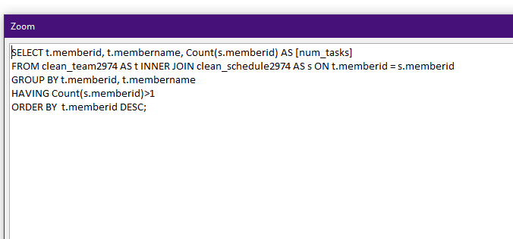

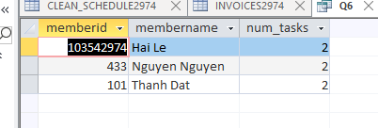

Q7: List all cleaning request in March

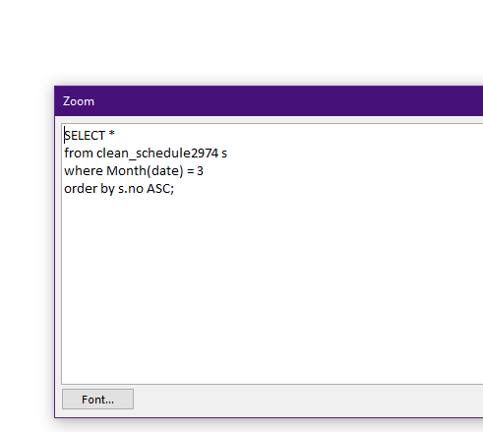

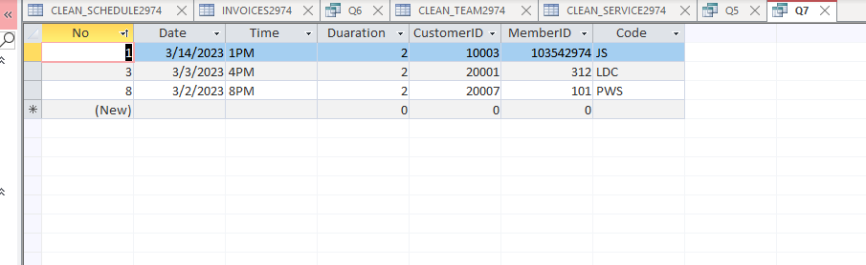

Q8: List the services that had been requested totally as the favourite service

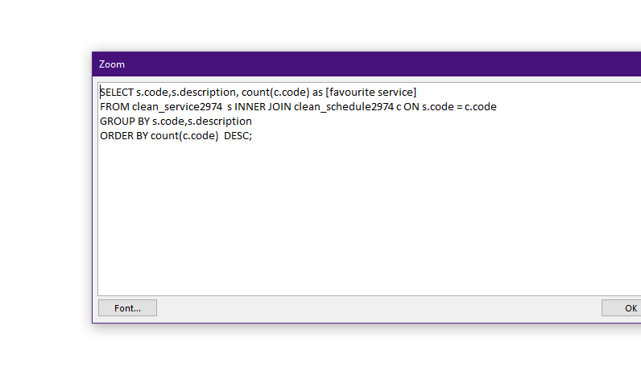

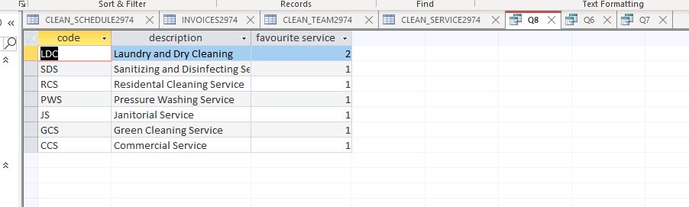

Q9: List the customer as royal customer which has the most request service

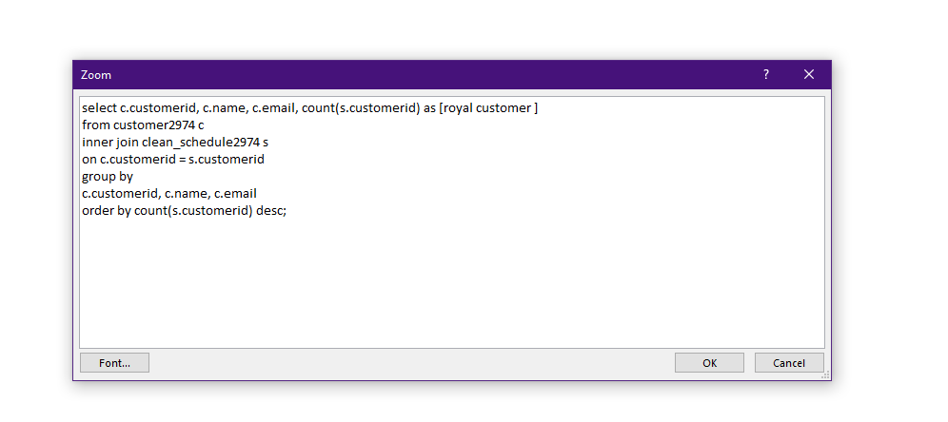

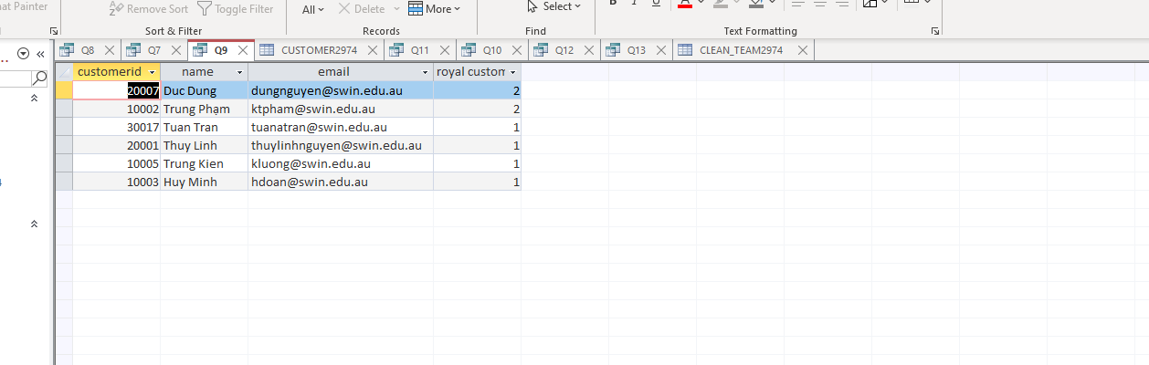

Q10: List all cleaning member which doesn’t finish any task

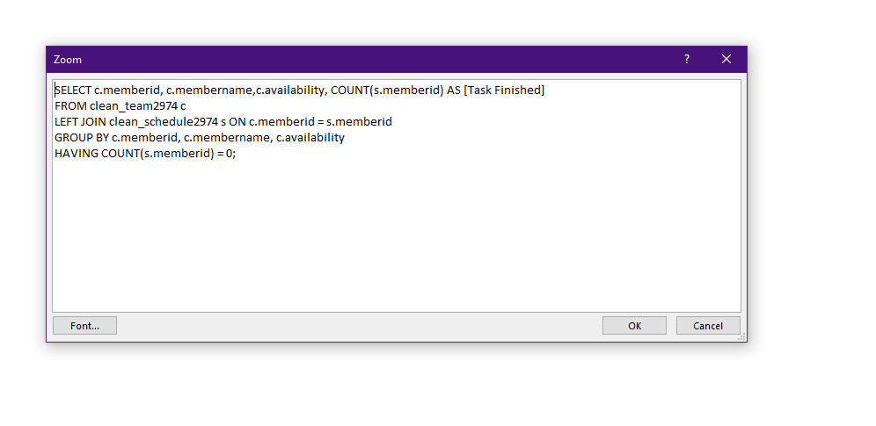

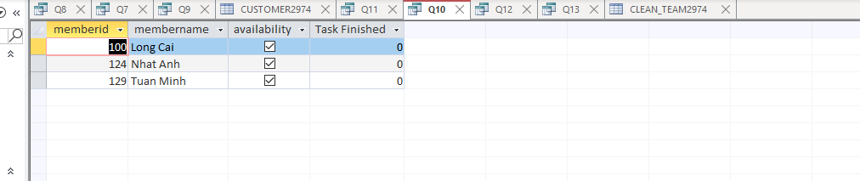

Q11: List customer that haven’t request any service

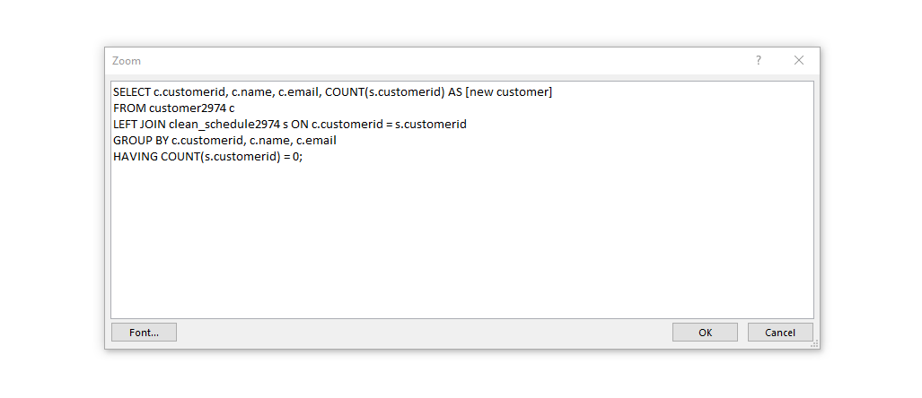

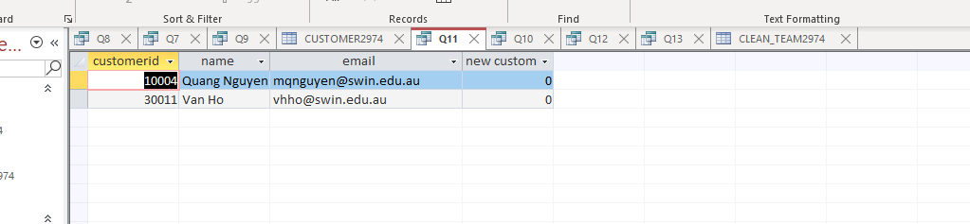

Q12: List the information of cleaning team member based on their earning as the input

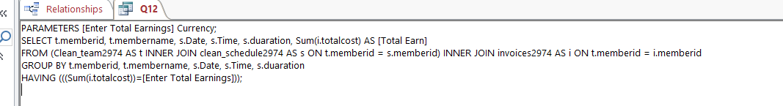

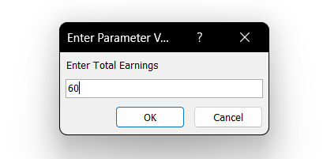

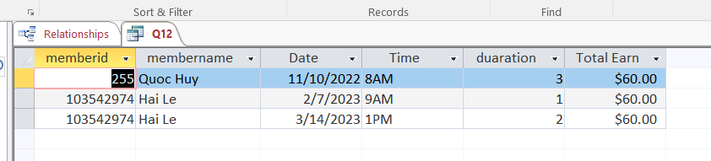

Q13: List the task that I do and my earning for each task

